
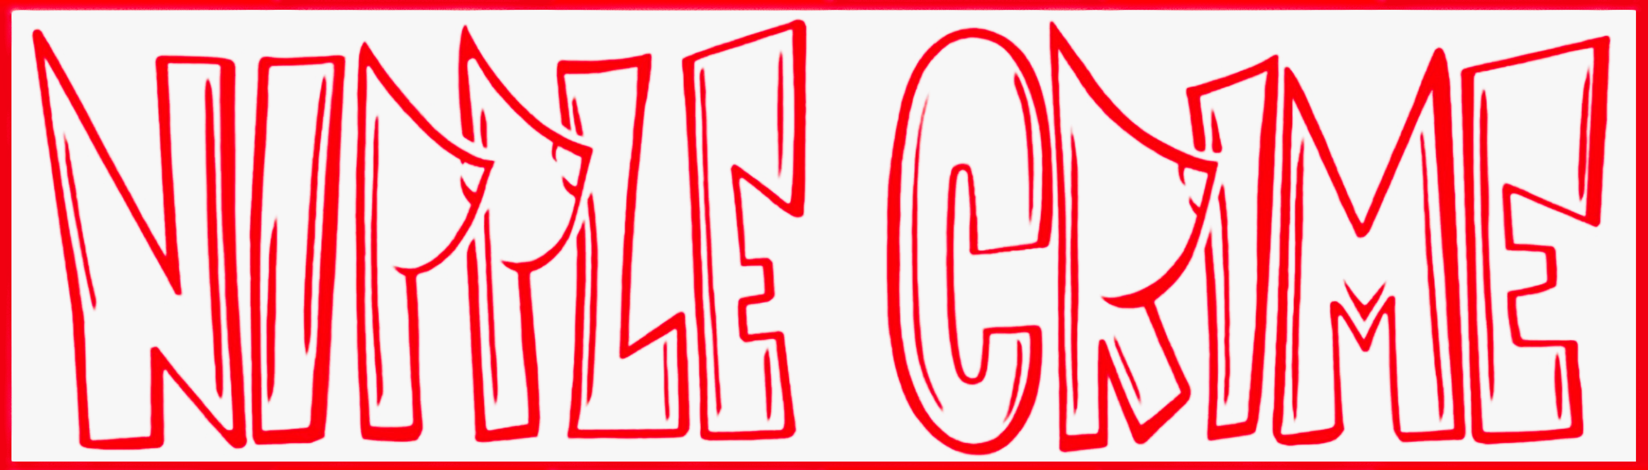

STANDARD OPERATING PROCEDURE
IRS 509(a)(2) Administration

SOP Number | Tr2 | Department | Treasurer
Version | 1.0 | Effective Date | 2026-03-04
Last Updated: 2026-03-04

1. Purpose
This SOP documents the annual compliance requirements for maintaining Nipple Crime's federal tax-exempt status under IRC Section 501(c)(3) with public charity classification under Section 509(a)(2). Compliance is owned by the Treasurer with oversight from the President.

2. IRS Determination Letter — Key Details
The original IRS determination letter (dated 05/06/2024) is the foundational legal document for the organization's nonprofit status. Key details from that letter:

- Legal Name: Camp NC Inc
- Address on Record: 527 S Arlington Ave, Reno, NV 89509
- Employer ID Number (EIN): 99-1556119
- Public Charity Status: 509(a)(2)
- Tax-Exempt Under: IRC Section 501(c)(3)
- Effective Date of Exemption: February 23, 2024
- Accounting Period Ending: January 31 (fiscal year end)
- Form 990 / 990-EZ / 990-N Required: Yes (annually)
- Contribution Deductibility: Yes -- donors may deduct contributions under IRC Section 170
- Addendum Applies: No
- IRS Document Locator Number (DLN): 26053516003724
- IRS Contact: Customer Service, ID 31954, (877) 829-5500

The original letter is filed at: [Shared Drive > Treasurer > IRS > Determination Letter 2024]
A copy should also be kept with the Secretary/President.

3. Annual Filing Requirements
Fiscal year end: January 31
Form 990 series due date: June 15 (15th day of the 5th month after fiscal year end)
Extension available: 6-month automatic extension to December 15 (file Form 8868 before June 15)

Which Form 990 to file (based on gross receipts):
- Form 990-N (e-Postcard): gross receipts normally $50,000 or less
- Form 990-EZ: gross receipts $50,001 - $200,000 AND total assets under $500,000
- Form 990 (full): gross receipts over $200,000 OR total assets $500,000 or more

Treasurer determines which form applies each year based on financials.
Filing is done at IRS.gov (tax-exempt organizations section) or through a CPA.

4. Annual Compliance Checklist
Complete the following each fiscal year (year end: January 31):

FEBRUARY (immediately after fiscal year end):
- Close the books for the fiscal year ended January 31
- Compile income and expense summary by category
- Reconcile all bank accounts
- Collect receipts and documentation for all expenses

MARCH - MAY:
- Determine which Form 990 applies (see Section 3)
- Prepare or engage CPA to prepare the return
- Board reviews draft Form 990 before filing
- President signs the return

BY JUNE 15:
- File Form 990 / 990-EZ / 990-N with IRS
- OR file Form 8868 for 6-month extension (if needed)
- Save filed return and IRS acknowledgment to: [Shared Drive > Treasurer > IRS > 990 > YYYY]

ONGOING:
- Notify IRS of any change in address or responsible party (Form 8822-B within 60 days)
- Do not allow status to lapse -- failure to file 3 consecutive years results in automatic revocation
- Keep determination letter accessible at all times (required to show donor deductibility)

5. What 509(a)(2) Means for Camp Operations
- Nipple Crime is classified as a publicly supported charity (not a private foundation)
- Donors may deduct contributions on their federal tax returns
- Camp must maintain broad public support -- dues, ticket sales, and participation fees generally qualify as public support under 509(a)(2)
- Excessive reliance on a single donor or source could jeopardize status -- flag to Treasurer if any single donor contributes more than 33% of total annual revenue
- Investment income is permissible but should remain incidental

6. Record Keeping
Retain all of the following for a minimum of 7 years:
- IRS determination letter
- All filed Form 990 / 990-EZ / 990-N returns
- Form 8868 extension requests (if any)
- Annual financial statements and bank reconciliations
- Board meeting minutes approving annual budget and major expenditures
- Any IRS correspondence

File location: [Shared Drive > Treasurer > IRS > ]

7. Contacts
- IRS Tax-Exempt Organizations: (877) 829-5500 (Customer Service ID: 31954)
- IRS Website: irs.gov/charities-non-profits
- Treasurer (filing owner): Isabel Hoy -- izhoy@yahoo.com
- President (signs returns, oversight): Reece Dassinger -- reece@nipplecrime.org
- VP / SOP Owner: Chris Reddin -- creddin1@hotmail.com

8. Revision History
- v1.0 | 2026-03-04 | Initial draft | Chris Reddin

